- Seek instruction/approval from your IT or IS support team
- Open Internet and go to Tools Internet Options
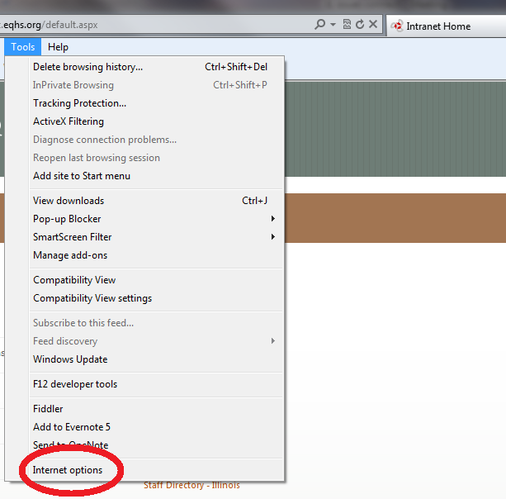
- The Internet Options Window will open. Your window may look slightly different depending on your IE version.
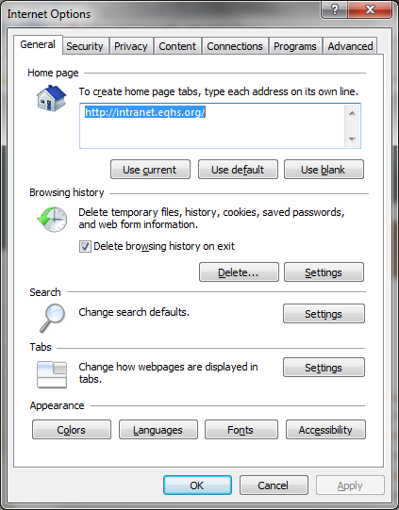
- In the Browsing History section press the Settings button.
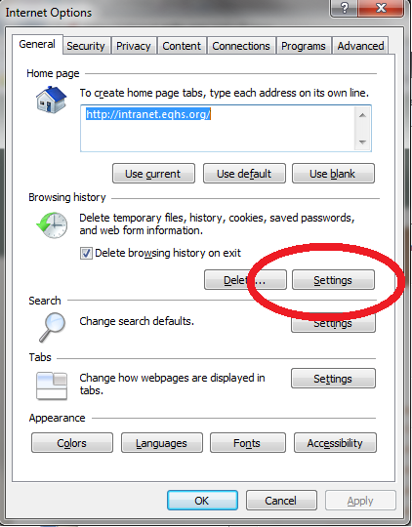
- On the Screen select the radio button next to “Every time I visit the webpage”.
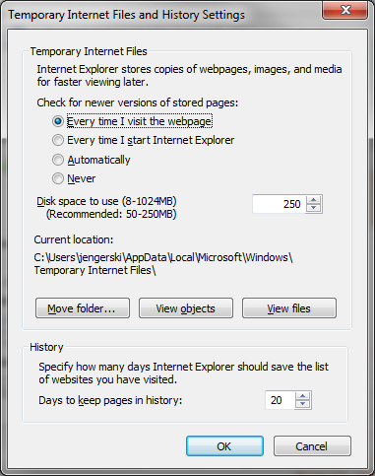
- Press OK on the Settings page.
- The press OK on the Internet Options page.

